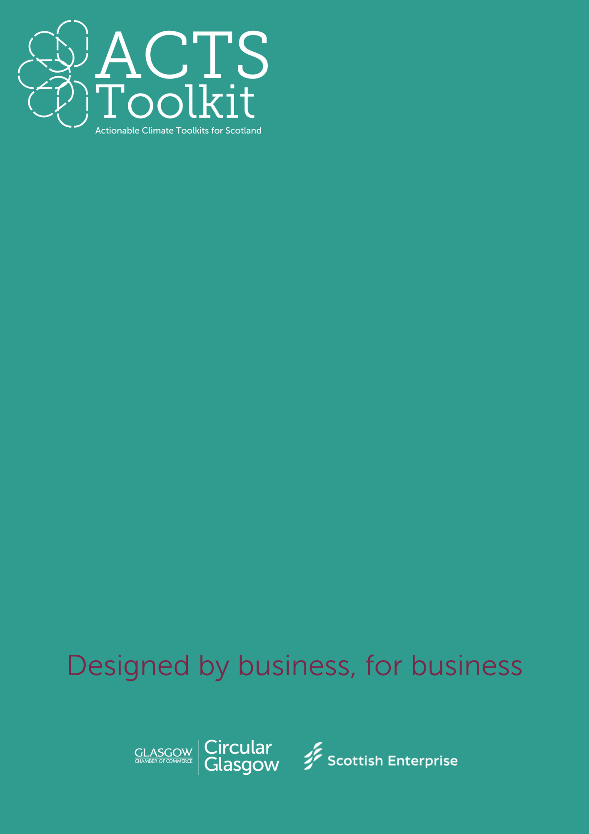

Third Sector and Community Outreach

Supplier Questionnaire Example

**Supplier Questionnaire – Example format**

|  |  |
| --- | --- |
| **Company Name** |  |
| **Services Provided** |  |
| **Contact email / tel** |  |
| **Location** |  |
| **Completed by (name / role)** |  |

(COMPANY) are working towards a more sustainable future. We are reviewing our business practices and working towards becoming a net zero organisation, as well as adopting circular economy principles. We kindly ask you to complete the below survey to the best of your ability.

**Example Questions**

1. Do you have an environmental or sustainability policy?

*(If yes, please provide a copy or summary)*

1. YES
2. NO
3. Does the business have any sustainability related accreditations, e.g. ISO14001, B-Corp?

*(If yes, please provide a copy)*

1. YES
2. NO
3. Does the business have any emission reduction targets?

*(If yes, please specify your targets and progress to date)*

1. YES
2. NO
3. Do you measure and/or report your Scope 1, Scope 2 and/or Scope 3 emissions?

*(If yes, please provide details*)

1. YES
2. NO
3. Do you have any measures in place to improve efficiency and/or reduce waste?

*(if yes, please provide examples)*

1. YES
2. NO
3. Are your raw materials ethically and sustainably sourced, e.g. certified FSC, Fairtrade.

*(if yes, please provide examples)*

1. YES
2. NO
3. Are you working towards a net zero target?

*(If yes, by when and what steps are you taking to get there?)*

1. YES
2. NO
3. Do you offer any schemes such as; material take back, refurbishment, recycling programmes; that are in line with circular economy principles?

*(If yes, please provide details)*

1. YES
2. NO
3. Do you engage with your own suppliers to improve sustainability within your own supply chain?
4. YES
5. NO
6. Do you have any additional comments?