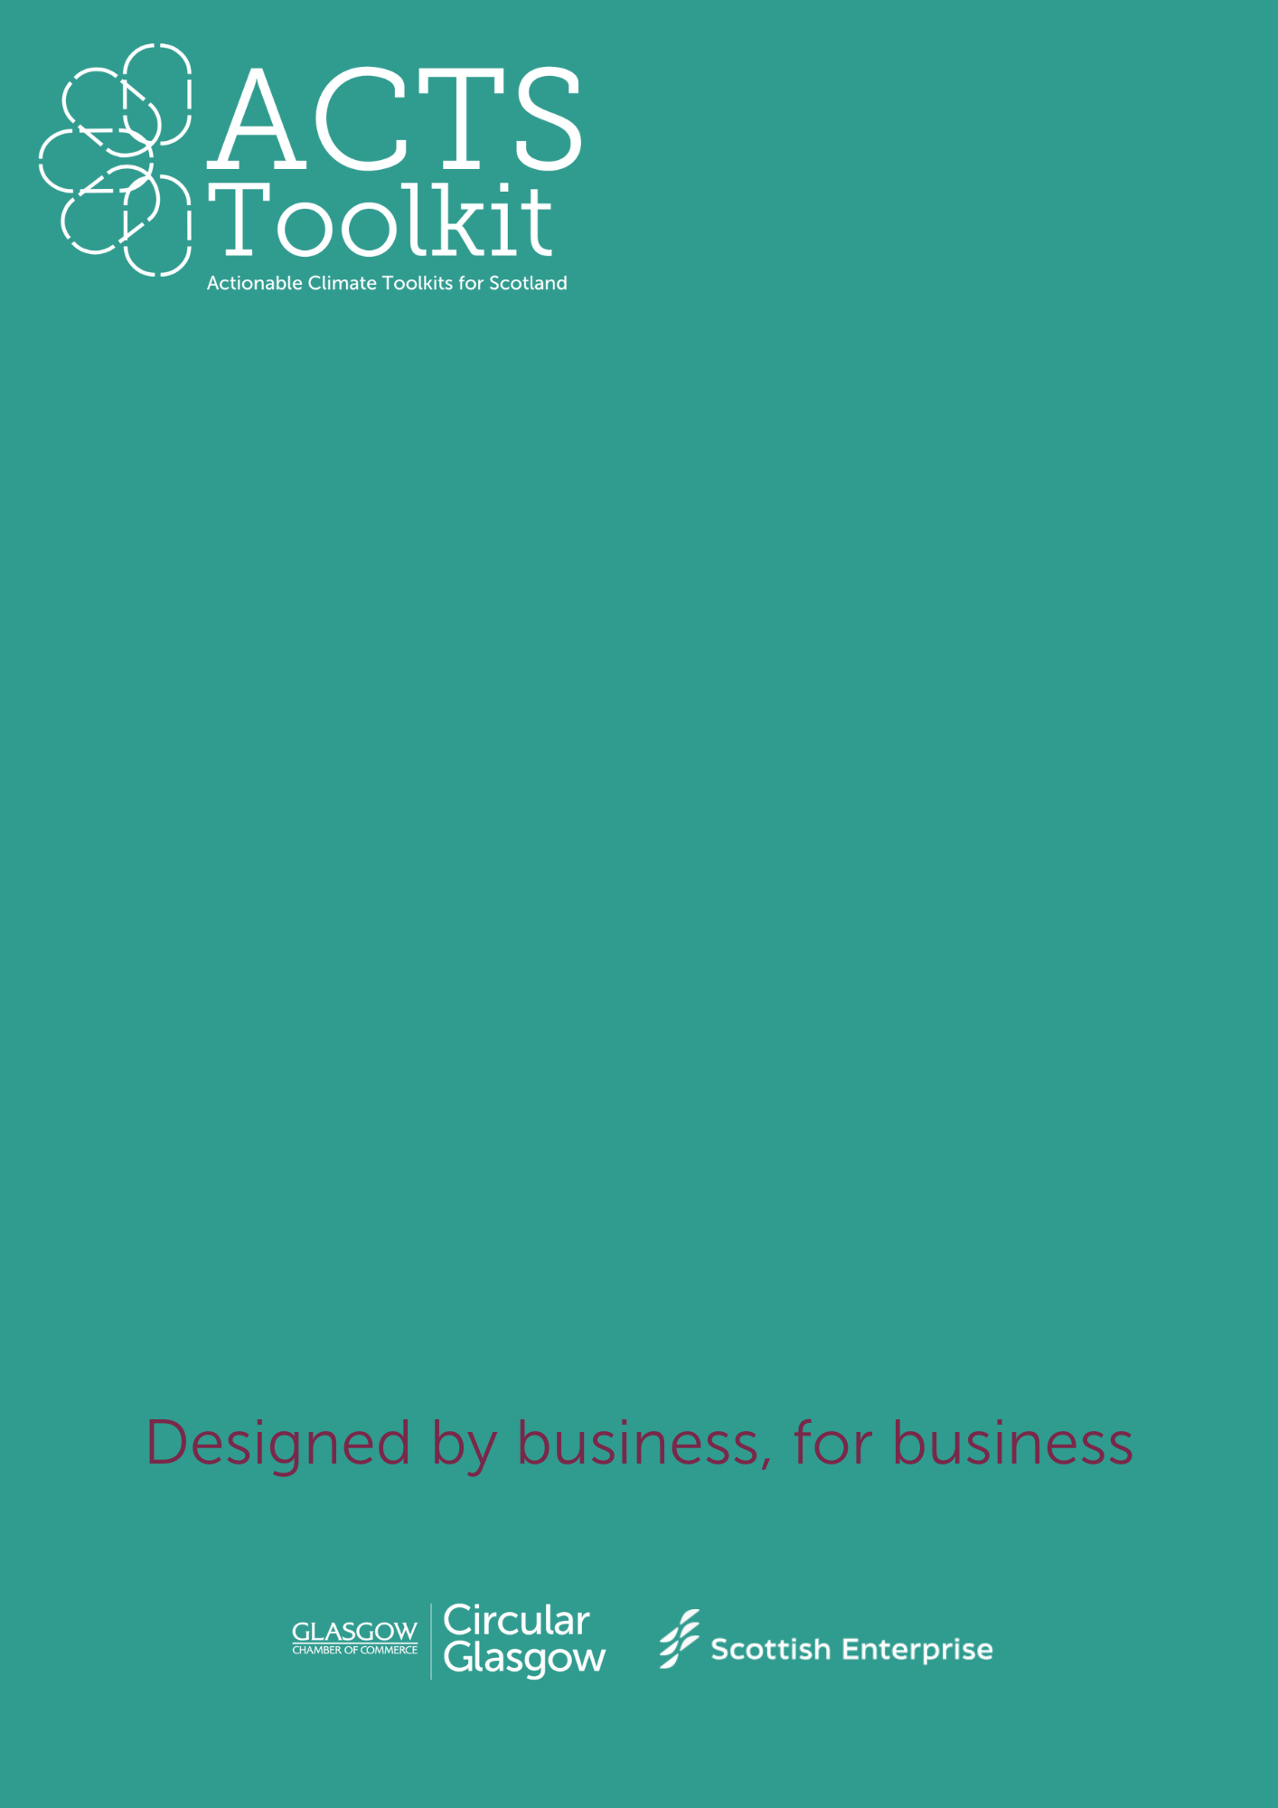 **Waste Audit Template**

Hospitality, Events and Attractions

Waste Audit Template

**General Information**

|  |  |
| --- | --- |
| **Business Name** |  |
| **Location of Audit** |  |
| **Date of Audit** |  |
| **Name of Auditor** |  |
| **Audit Scope** *(e.g. office, Site 1, etc)* |  |

**Categories of Waste**

Review and assess the volumes for the following waste categories (use weight, volume, or percentage for measurement):

|  |  |  |  |
| --- | --- | --- | --- |
| **Waste Category** | **Estimated Volume/Weight** | **Disposal Method** | **Comments** |
| Paper and Cardboard |  |  |  |
| Plastics |  |  |  |
| Metals (e.g., cans) |  |  |  |
| Glass |  |  |  |
| Organic Waste |  |  |  |
| Hazardous Waste |  |  |  |
| General Waste |  |  |  |

**Recycling and Reuse Practices**

Evaluate the effectiveness of current recycling and reuse efforts:

* **Recyclables Separation:** Yes/No
* **Reuse Opportunities (e.g., packaging):** Yes/No
* **Recycling Rate (estimated %):**

**Waste Disposal Methods**

Detail how waste is currently being disposed of:

|  |  |  |
| --- | --- | --- |
| **Disposal Method** | **Volume/Weight** | **Comments (e.g., frequency, costs)** |
| Landfill |  |  |
| Recycling Facilities |  |  |
| Composting |  |  |
| Incineration |  |  |

**Cost of Waste Management**

* **Collection/Disposal Fees:**
* **Recycling Costs or Revenues:**
* **Other Associated Costs:**

**Opportunities for Improvement**

List actionable recommendations to reduce waste:

* **Waste Reduction Strategies:**
* **Improved Recycling/Separation:**
* **Partnering with Recycling Services or Donation Programs:**