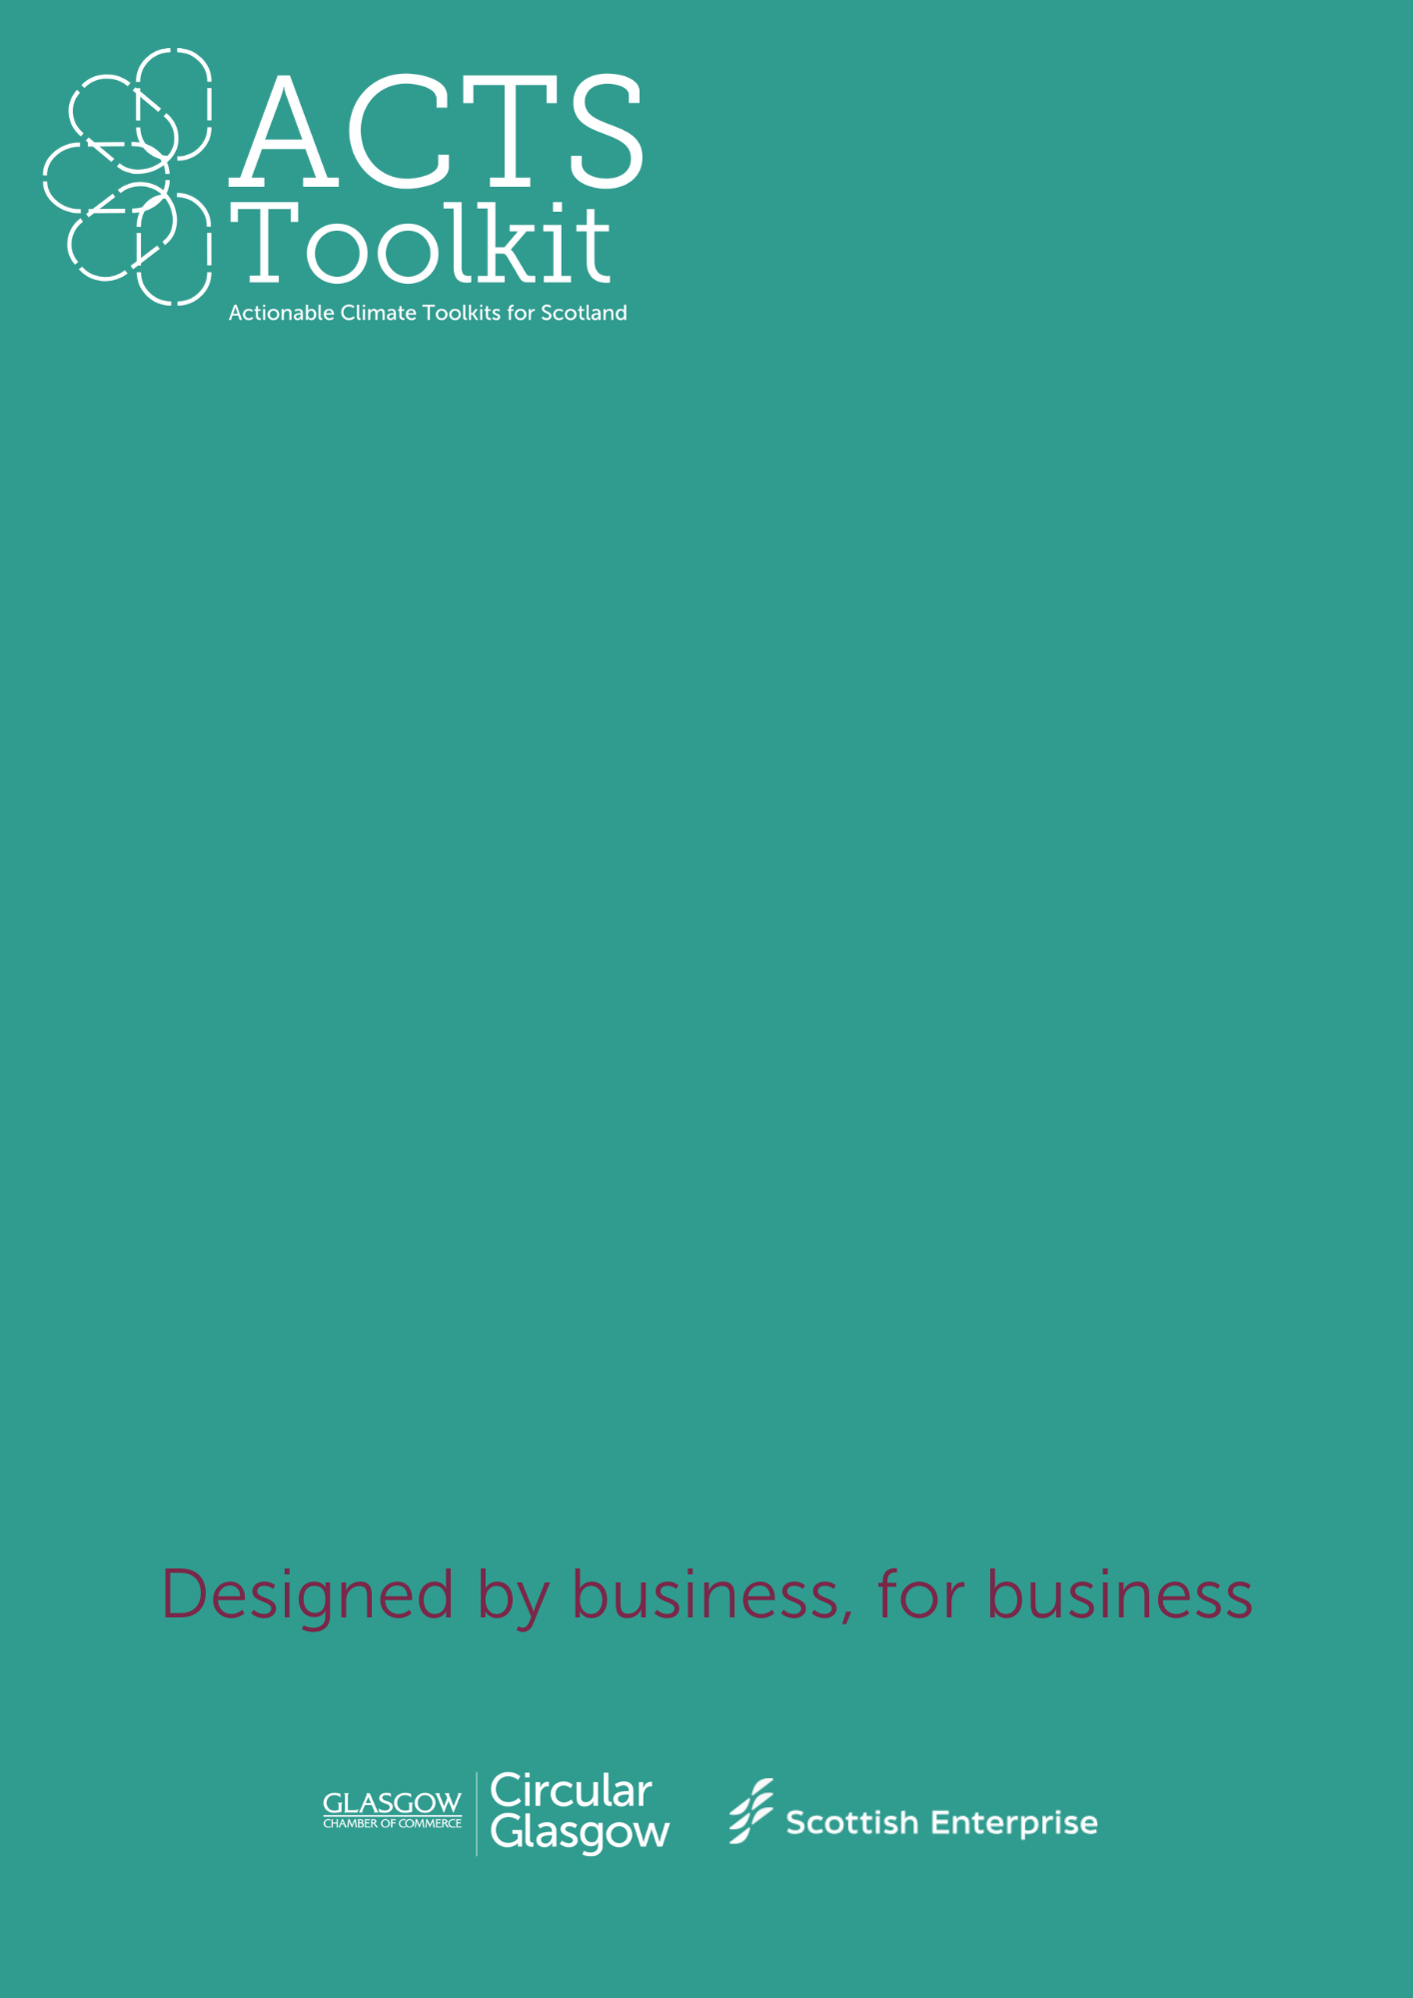

Hospitality, Events and Attractions

Supplier Email Template

**Supplier Email Template**

*The following email template is designed to send to suppliers alongside the Self Certification Supplier Questionnaire.*

*You can use it as the foundation for communications with suppliers and it can be easily modified to make it relevant for specific businesses.*

Dear *[supplier*],

I hope this email finds you well. [*A tailored message about the importance of the business’s relationship with the specific supplier.*]

As a business striving to reduce its environmental impact, we are taking positive steps towards our sustainability goals. This includes [*state some of the business’s specific targets e.g. net zero by 2045, increased circularity, increasing the amount of recycled materials in products*]. As sustainability is integral to the continuous improvement of [the business], we are currently reviewing our working practices.

Working with our suppliers is key to delivering [*services/products*] that align with our values and goals, and we are committed to building trust and transparency within our supply chain. [*You could attach your environmental policy & commitments to the email to share your own responsibilities*] We are reaching out to request that you share your own environmental policy or ESG statement, and any other relevant documentation with us that demonstrates your own sustainability efforts. From there, we can represent [*supplier*] and its [*services/products*] more accurately and effectively to [*customers/clients/visitors/business network*]. It will also allow us to continue to make informed decisions about our supply chain.

If you require any additional information from [*business*] regarding our own sustainability journey, we would be keen to share our progress and offer any support.

Thank you for your ongoing support. We look forward to continuing our working relationship and working towards a more sustainable future together.

Sincerely,

[*Business*]