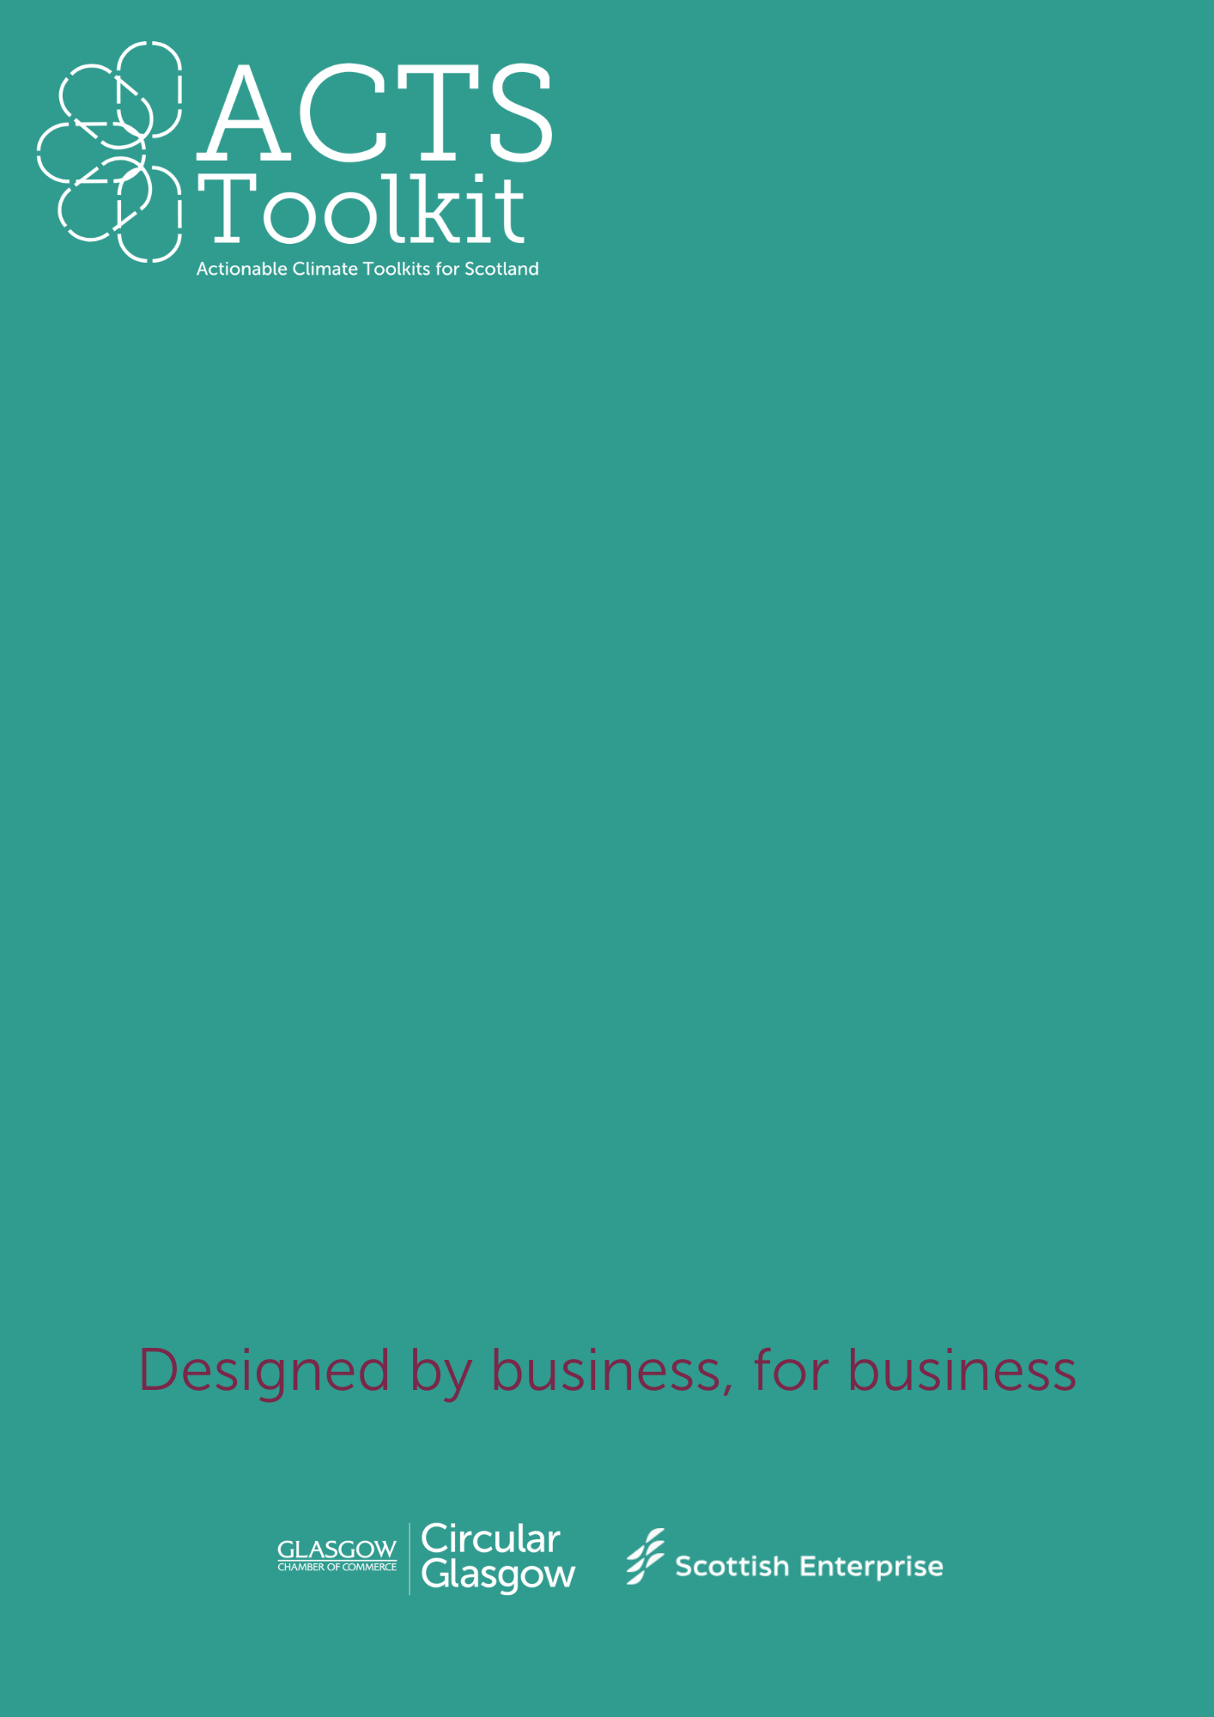
Environmental Policy Checklist
Environmental Policy Checklist
Built Environment and Construction
Date
Reviewed by
Policy Document Name

Use the checklist below to evaluate your policy document(s).
Area of compliance | Meets compliance
- Clearly outlines business commitments to sustainability, including Net Zero targets. | (Y / N)
- Demonstrates compliance with environmental regulations, e.g. Environment Act 2021, ISO 14001 Certification, Sustainable Development Goals.

- Specifies which operations, departments, or area of business that the policy applies to.

- Identifies the which Scope 1, Scope 2 and/or Scope 3 emissions are included.

- Establishes measurable targets that reduce your business’s environmental impact.

- Details clear objectives, including who will be responsible.

- Ensures effective stakeholder engagement, both internally and externally.

- Commits to continuous improvement through regular review, audits and policy updates.

- Policy Includes clear tracking and reporting mechanisms.

- Policy is easily accessible, available and approved by management.

