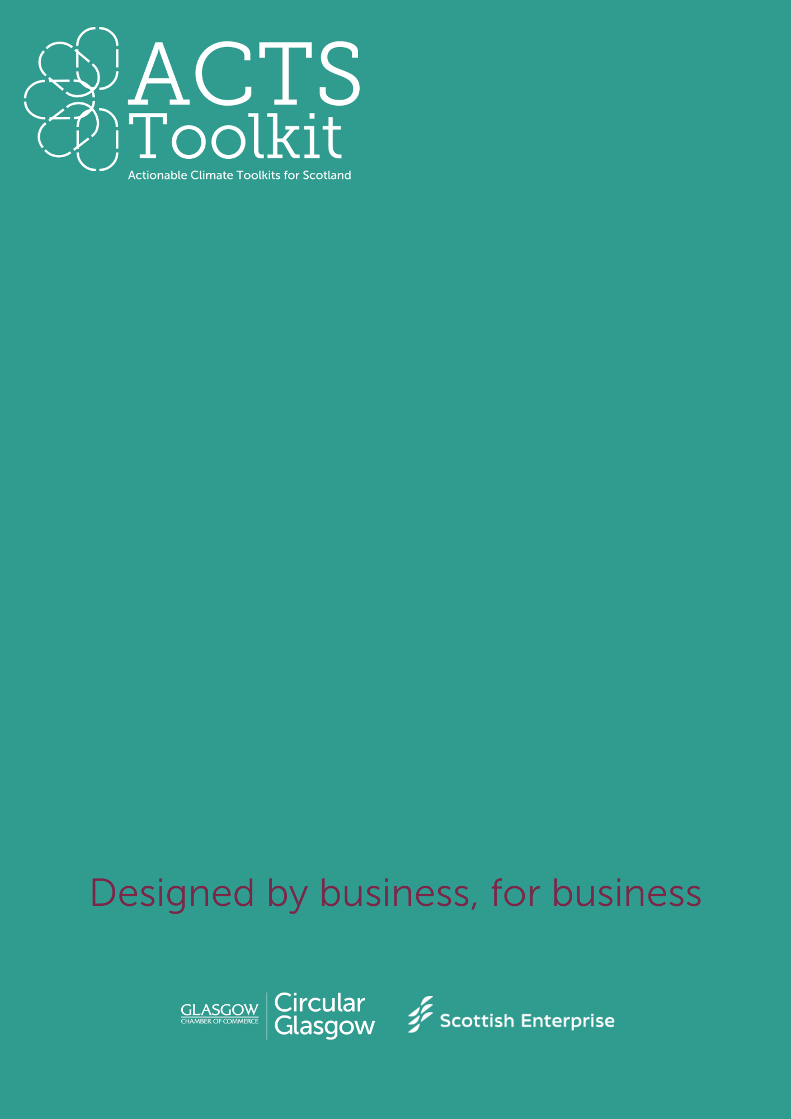

Arts, Creative and Retail

Mapping your Supply Chain

**Mapping your Supply Chain**

Think about the products and services that you sell, and who supplies the materials for them. As an SME, you could have multiple different suppliers, or very few. Start by listing your suppliers.

|  |  |  |  |  |  |  |
| --- | --- | --- | --- | --- | --- | --- |
| **Supplier Name** | **Products / Materials / Services provided** | **List all of the packaging from Supplier** | **What happens to the packaging currently?** | **How far do your goods travel? (miles)** | **How frequently do they deliver/collect?** | **Additional Notes** |
| *SUPPLIER A* | *Branded cardboard boxes for products to be delivered in.* | *Pallet*  *Plastic Wrap*  *Cardboard protectors* | *Pallet – returned*  *Plastic wrap – bin*  *Cardboard protectors - recycled* | *75 miles* | *Deliver – every 2 months* | *Find closer supplier to reduce distance travelled.* |
|  |  |  |  |  |  |  |
|  |  |  |  |  |  |  |
|  |  |  |  |  |  |  |
|  |  |  |  |  |  |  |
|  |  |  |  |  |  |  |
|  |  |  |  |  |  |  |
|  |  |  |  |  |  |  |
|  |  |  |  |  |  |  |
|  |  |  |  |  |  |  |
|  |  |  |  |  |  |  |
|  |  |  |  |  |  |  |
|  |  |  |  |  |  |  |
|  |  |  |  |  |  |  |
|  |  |  |  |  |  |  |
|  |  |  |  |  |  |  |
|  |  |  |  |  |  |  |
|  |  |  |  |  |  |  |