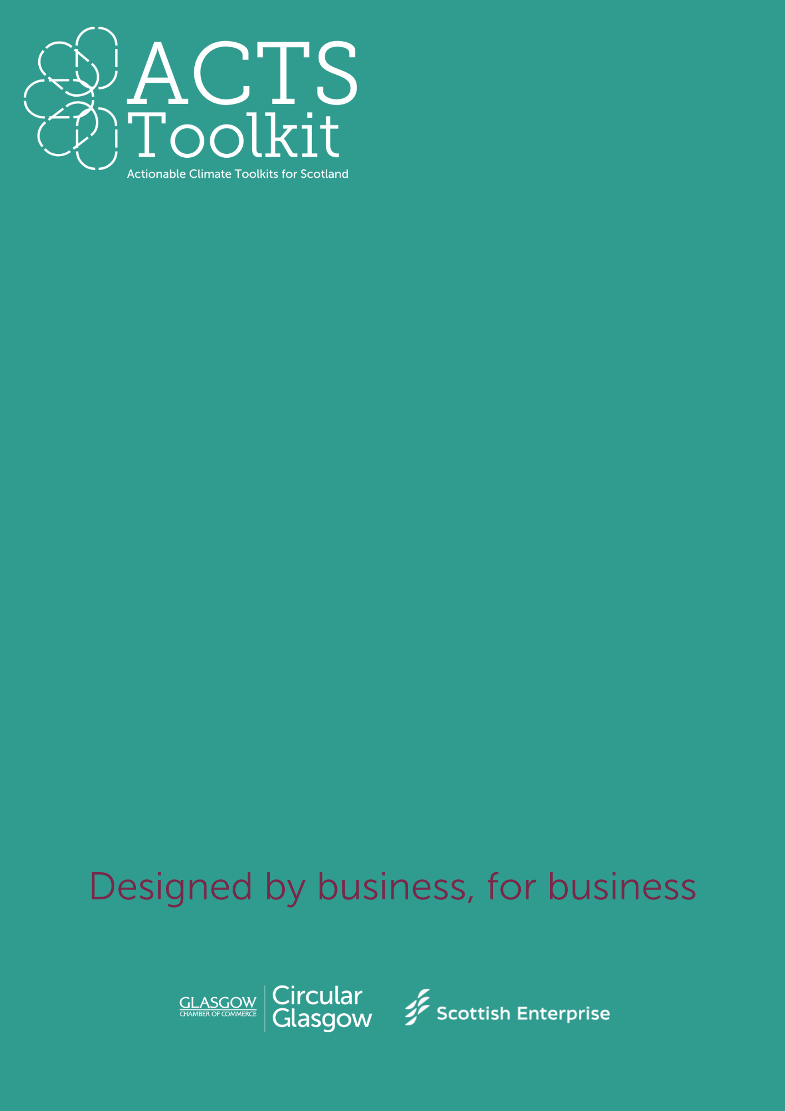

Where to start

Initial Assessment

**INITIAL ASSESSMENT**

**Step one**

Use the Self-Assessment tool below to establish where you are on your sustainability journey. Highlight the box that best describes the stage you are at.

**Step two**

Select the sector that represents your business or organisation. Using the results from your assessment, we’d recommend reading through each of the resource introduction pages to figure out your starting point.

We’ve grouped all the information into **five core resource areas**:

* **Carbon Footprint** – work towards calculating your carbon footprint
* **Travel** – tips and examples on how to make more sustainable travel choices
* **Procurement & Supply Chain** – make sure your supply chain supports your goals
* **Waste Management** – highlight and reduce areas of waste in your business
* **Policies** – communicate your goals and practices, internally and externally

Each group has different **stages**, depending on where you’re at with your existing sustainability journey:

* Stage 1 / Beginner
* Stage 2 / Intermediate
* Stage 3 / Expert

**Step three**

Work through each resource group that is relevant for your business or organisation. Track your progress using the below tracker table.

There are downloadable tools and guides that will help you to create documents and measure your environmental impact. These can then be used to demonstrate your work towards embedding sustainability, becoming net zero or embracing the circular economy model.

You could use these documents to support your:

* Funding applications
* Bid and Tender processes
* Marketing materials to help differentiate you from your competition
* Communicate your sustainability credentials to your clients, customers and visitors

|  |  |  |  |
| --- | --- | --- | --- |
| **CORE RESOURCE GROUP** | **BEGINNER** | **INTERMEDIATE** | **EXPERT** |
| **Policies** | We do not have formal sustainability policies or documentation. | We have some internal sustainability policies but limited external communication. | We have a documented sustainability strategy, communicate progress publicly, and engage stakeholders. |
| **Carbon Footprint** | We have not yet measured our carbon footprint. | We have estimated our carbon footprint using basic tools or rough calculations. | We regularly measure, report, and set targets for reducing our carbon footprint using verified methods. |
| **Procurement and Supply Chain** | We have not assessed the sustainability of our suppliers. | We have started reviewing supplier sustainability credentials and considering sustainability in procurement. | We prioritise sustainable suppliers, require environmental standards, and regularly audit procurement processes. |
| **Commuting and Travel** | We do not track employee travel or business-related emissions. | We track some aspects of business and commuting travel but lack formal reduction strategies. | We have detailed records, policies, and incentives to reduce travel emissions (e.g., remote work, EV incentives, carbon offsetting). |
| **Waste Management** | We have basic waste management but no clear reduction strategy. | We recycle and reduce waste but do not have a formal waste policy or regular audits. | We follow a circular economy approach, track waste reduction, and work towards zero waste goals. |

**PROGRESS TRACKER**

|  |  |  |  |
| --- | --- | --- | --- |
| **CORE RESOURCE GROUP** | **BEGINNER** | **INTERMEDIATE** | **EXPERT** |
| **Policies** |  |  |  |
| **Carbon Footprint** |  |  |  |
| **Procurement and Supply Chain** |  |  |  |
| **Commuting and Travel** |  |  |  |
| **Waste Management** |  |  |  |