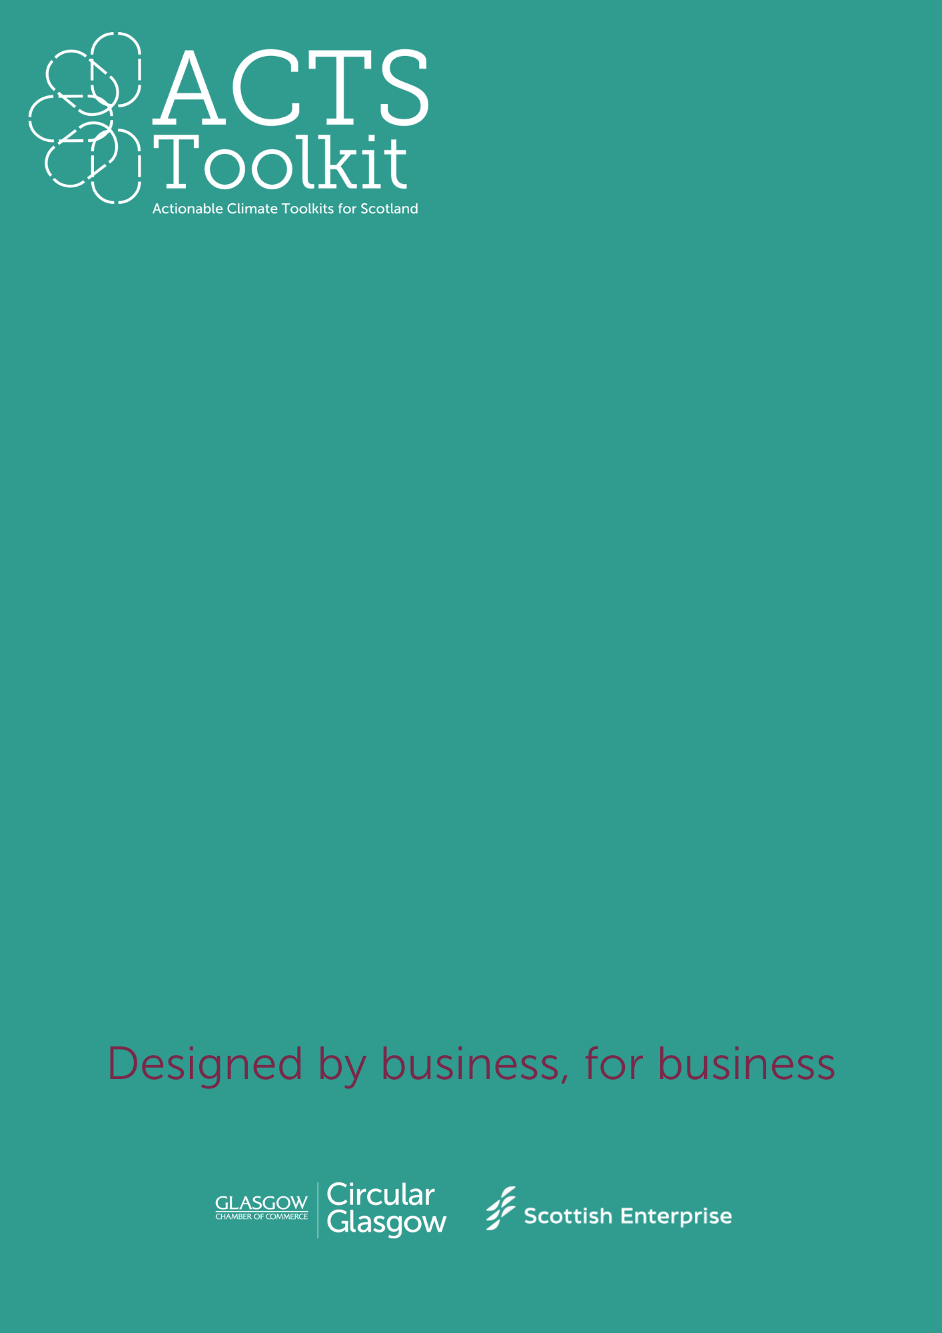
Values and Motivations
For
Sustainability
Services and Manufacturing
Exercise: Understand Your Values and Motivations
Start by reflecting on why sustainability matters to your business.
Either complete this exercise as an individual, or as part of your first Green Team meeting.
Defining Your Sustainability Values
Ask yourself or your team the following questions and note your responses:
- What are our core values as a business?

- Why do we want to become more sustainable (e.g., reducing costs, improving brand reputation, regulatory compliance, or environmental stewardship)?

- What specific environmental impacts does our business have (e.g., energy use, waste, transportation)?

- How do our customers, employees, or stakeholders value sustainability?

- Any other points:

